

[Exam 1]

**Question Set A**

|  |  |
| --- | --- |
| **Instructor:** | Ashrafur Rahaman |
| **Class:** | 2020W CSD 2214 2 |

|  |
| --- |
| * Read all questions carefully. * Partial marks may be awarded where appropriate. * Time allowed:90 minutes * Total marks: 20 |

|  |  |
| --- | --- |
| **Date:** | 07-March-2020 |
| **Student Name:** | SERGIO IVAN SANCHEZ SOLANO |
| **Student Number:** | C0767520 |

**Exam Rules:**

1. You need to solve two problems in your computer.
2. You must create a folder in your computer named “2214-Exam1-YourStudentID”
3. Create two folders named (YourStudentID-Answer1 and YourStudentID-Answer2) inside the folder “2214-Exam1-YourStudentID”
4. Inside “YourStudentID-Answer1” folder you will have HTML file named “YourStudentID-A1.html”
5. Inside “YourStudentID-Answer2” folder you will have HTML file named “YourStudentID-A2.html”
6. You can create JS, CSS, Image or any other folder you need or like inside “YourStudentID-Answer1” and “YourStudentID-Answer2”
7. Do not use any online JavaScript/CSS framework and/or library.

**How to submit your exam paper:**

1. Write Answers and add screen shot in this document.
2. Copy this document file (including your answer) into “2214-Exam1-YourStudentID” folder.
3. Compress the entire folder and upload in moodle.

**Question 1 (10 Marks)**

**User JQuery and JQueryUI library to solve this problem. Ensure that JQuery, JQUery UI framework files are downloaded to your local computer.**

Create an Accordion with 5 sections in it. The ID of the Accordion must be “YourStudentID-accordion” (2 marks)

The Accordion must have “Customize Icons” option (1 mark)

Also add “Collapse Content” option for the accordion (1 mark)

Inside Section 1 of the Accordion enter 3 textbox named “YourStudentID-FirstName”, “YourStudentID-LastName”, “YourStudentID-DOB”. For YourStudentID-DOB use datepicker widget. (2 mark)

Inside Section 3 of the Accordion enter 2 images. Inside Section 5 of the Accordion enter 2 button “OK” and “Cancel”. For both of the button use jQuery UI “Button” Widget. (1 mark)

When you click on “OK” button a JQuery Dialog will come up. (1 mark)

**Answer here:**

Explain your answer (2 marks).

Screen shot of the following things need to be added:

1. HTML Code

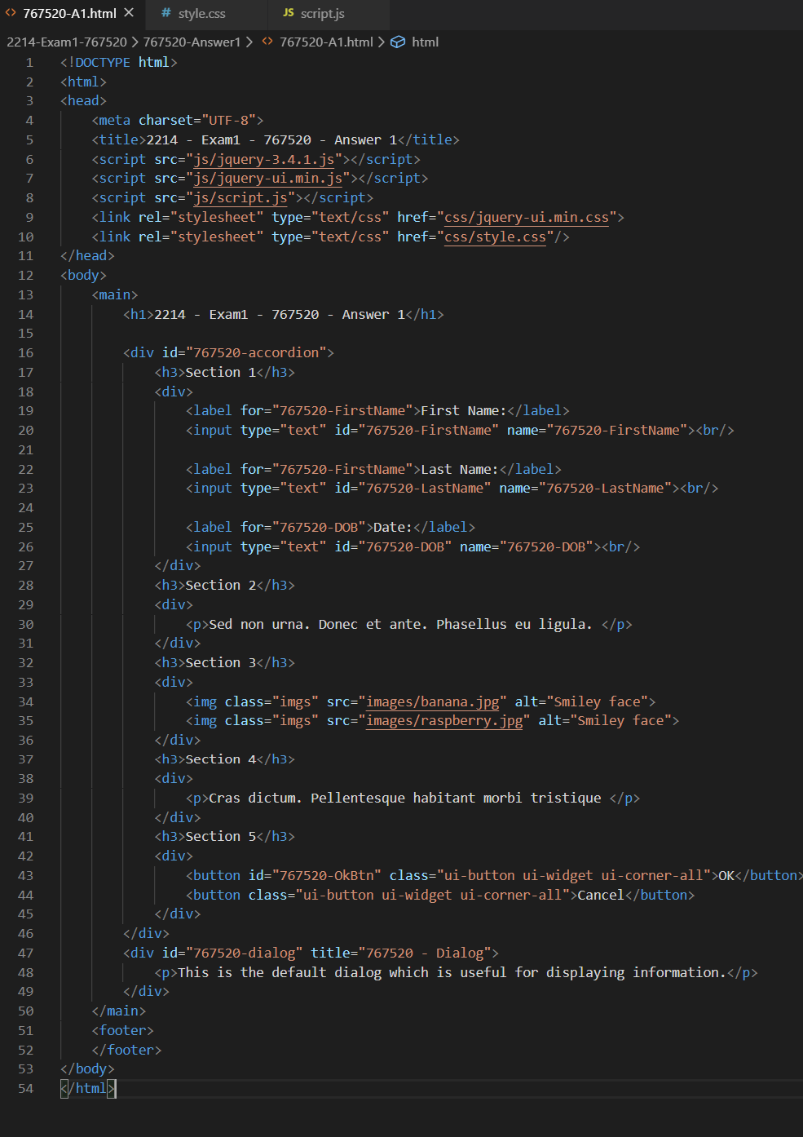

1. JS Code

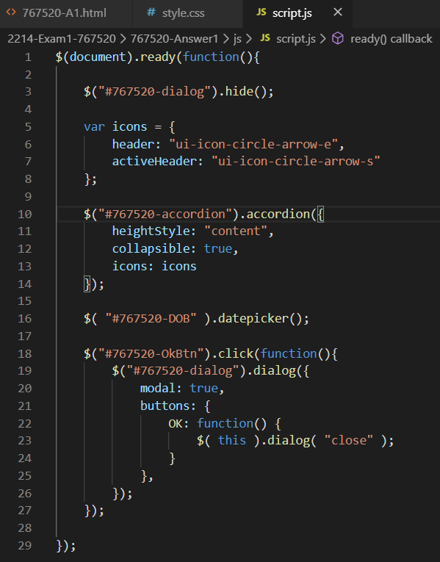

1. Output Screen when page loads

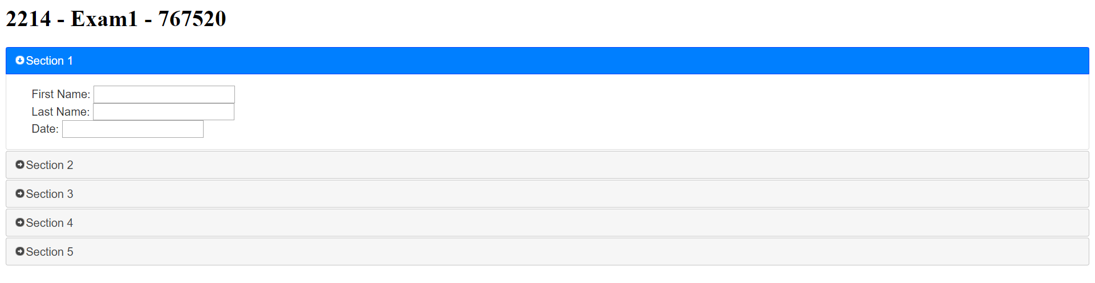

1. Output screen of each accordion section

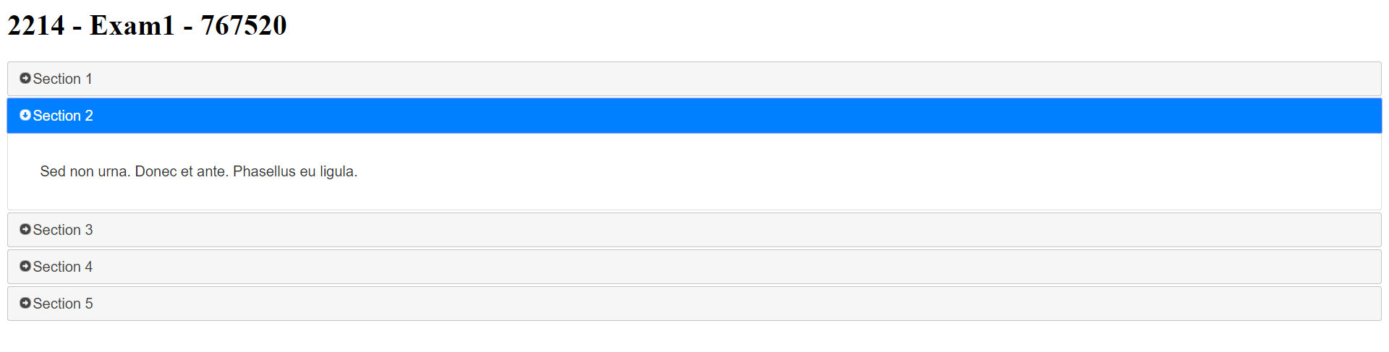

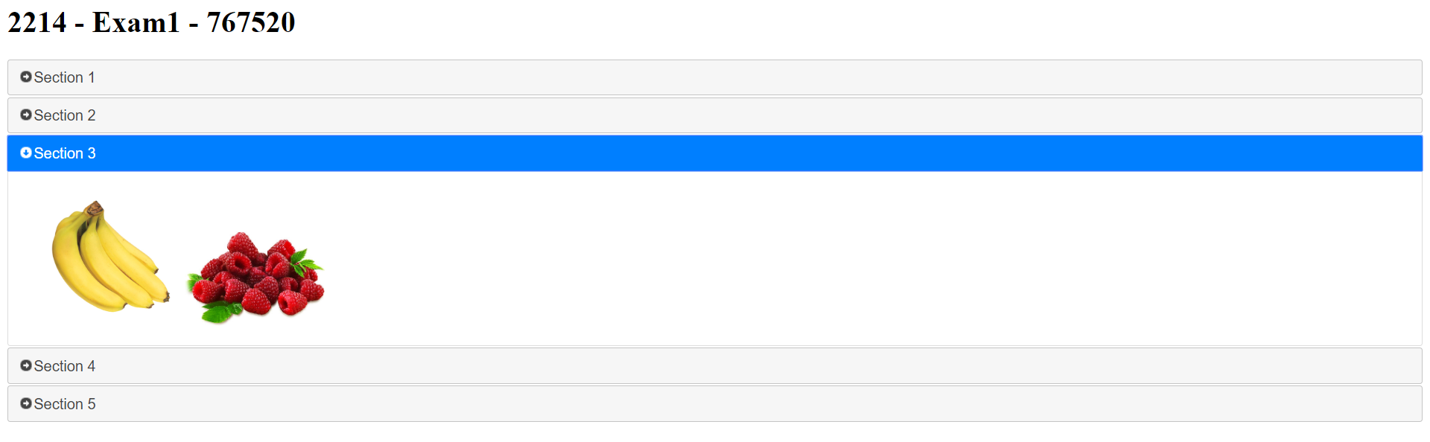

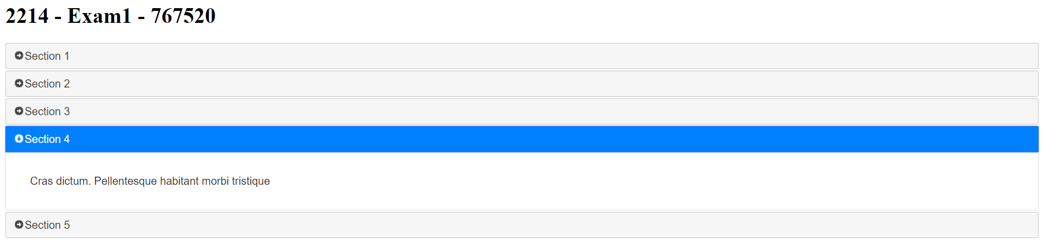

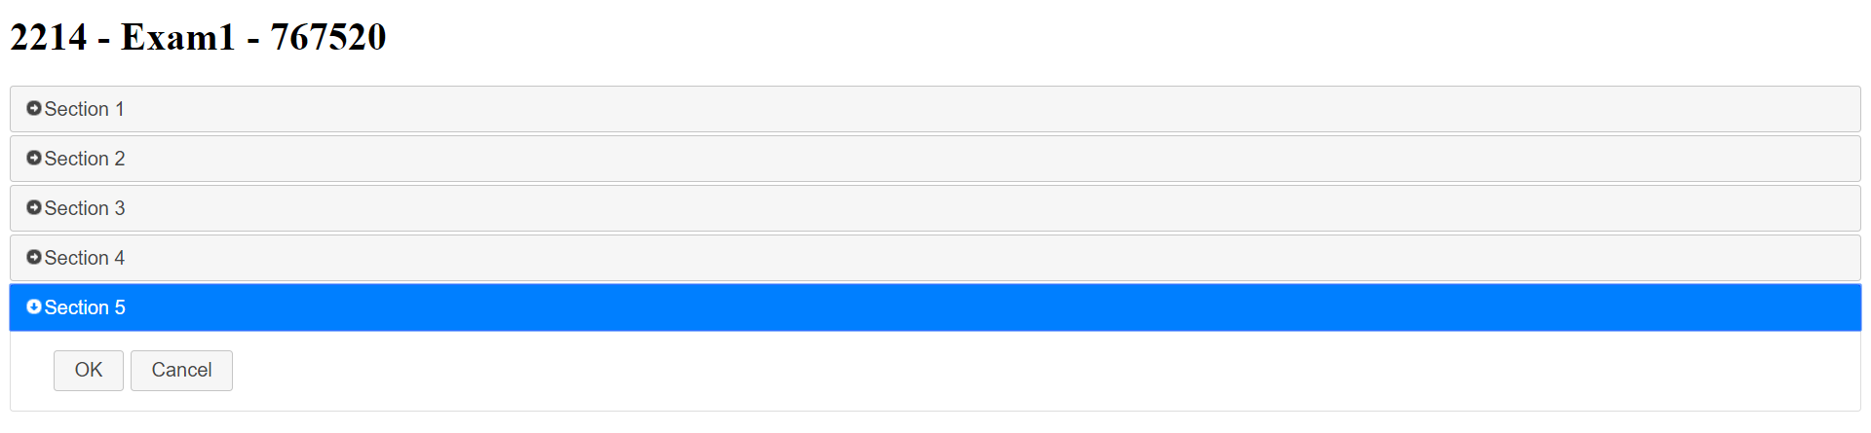

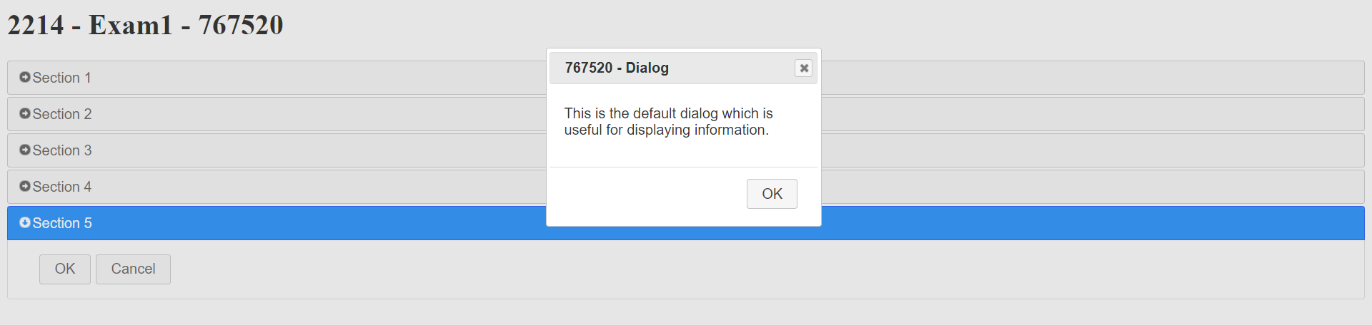

**Question 2 (10 Marks)**

**Solve this problem using HTML, CSS, and JavaScript. Do not user JQuery Library.**

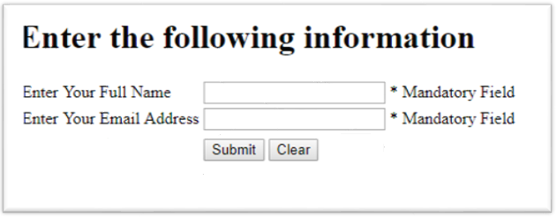

Create HTML page like above. The ID of the textboxes will be “*YourStudentID_FullName*”, “*YourStudentID_Email*”. For “* Mandatory Field” use span and **do not use any ID**. (2 marks)

Write JQuery Codes for the following actions:

1. When you click on submit button (4 marks)
   1. If *YourStudentID_Fullname* is empty then “* Mandatory Field” will be changed to “Please enter Full Name”
   2. If *YourStudentID_Email* is empty then “* Mandatory Field” will be changed to “Please enter Email Address”
   3. If both FullName and EmailAddress have value you will show the name, email address in a paragraph under the Submit and Clear button. The ID of the paraghaph will be “*YourStudentID_Output*”
2. When you click on the clear button (2 marks)
   1. “YourStudentID_FullName”, “YourStudentID_EmailAddress” will be empty
   2. “* Mandatory Field” text will be reset for both “YourStudentID_FullName” and “YourStudentID_EmailAddress”

**Answer Here:**

Explain your answer (2 marks).

Screen shot of the following things need to be added:

1. HTML Code

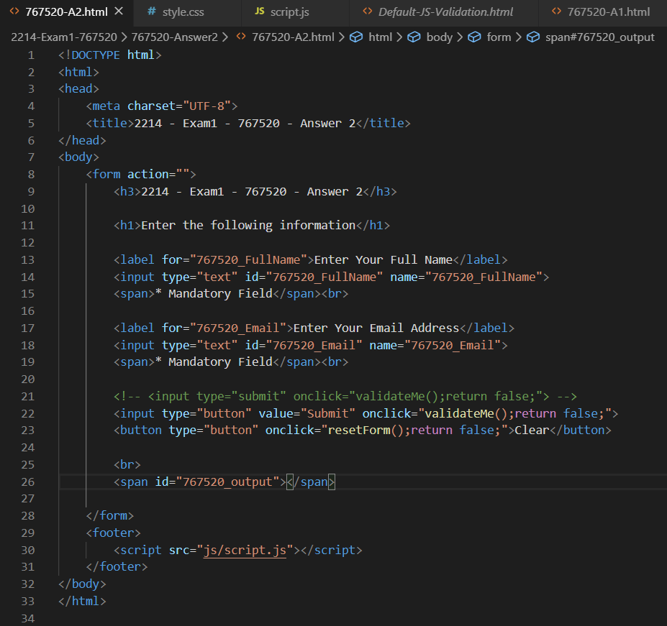

1. JS Code

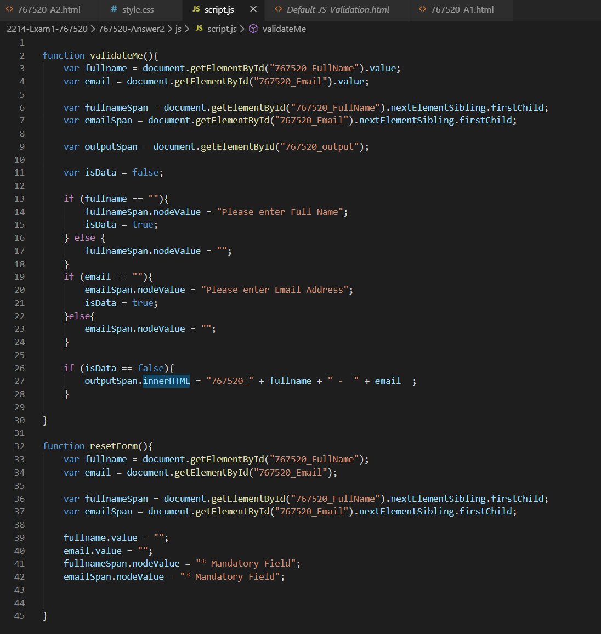

1. Screen shot of the page when first loads

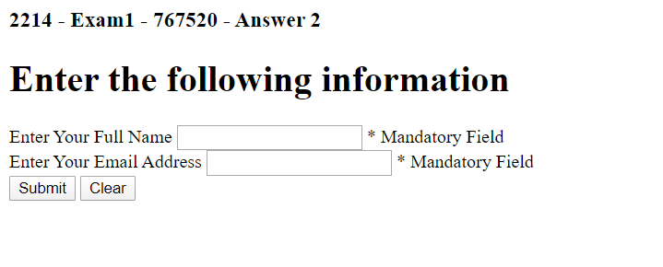

1. Screen Shot of the page when click on submit button (with validation and without validation)

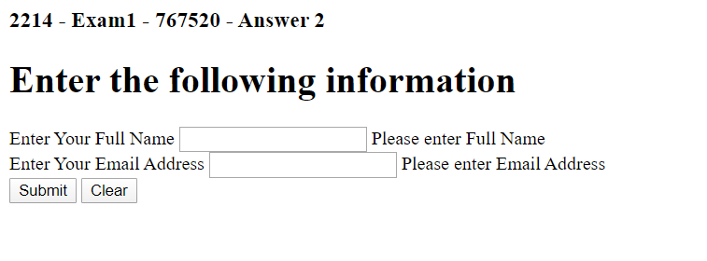

1. Screen Shot of the page when you click clear button

